**Sixth Sunday of Easter**

**May 25, 2025**



**Bethany Lutheran Church**

**2515 Madison Ave., Burlington, IA**

**Phone: (319) 752-3621**

[www.bethanyburlington.org](http://www.bethanyburlington.org)

*Bethany’s Mission Statement: Reaching out in Worship, Fellowship, Learning and Love – we are God’s people.*

We are so glad you chose to worship with us this morning. We hope everyone

feels welcome as we strive to serve and strengthen each other in faith toward God and in love toward all. Now, as you wait for the service to begin, please relax, enjoy the music, and quiet your heart before God.

**Sixth Sunday of Easter**

*ELW indicates that hymns or liturgy are taken from Evangelical Lutheran Worship–red hymnal*

# PRELUDE

# Welcome, Birthday/Anniversary Bank

# *(money given to Bethany’s Human Concerns Fund)*

**We Gather to Acknowledge God’s Presence**

**Thanksgiving for Baptism**

P: Alleluia! Christ is risen.

**C: Christ is risen, indeed. Alleluia!**

P: In the name of ☩ the One who was, who is, and who is to come.

**C: Amen.**

P: Baptized into Christ’s death and resurrection, and called to live the baptized life, let us give thanks for the gifts of baptism. *Water may be poured before or during the thanksgiving.* Holy God, we give you thanks for the waters of baptism, waters that make a people your own, that restore to wholeness, and empower us to be witnesses in your name. Baptized into you, O Living One,

**C: make us one as you are one.**

P: We give you thanks for the waters of baptism, waters that strengthen believers and give new life to beloved servants of your church; waters that extend your boundless love and cross barriers of our own making. Baptized into you, O Living One,

**C: make us one as you are one.**

P: We give you thanks for the waters of baptism, waters that open the hearts of believers and give a voice in the night to those in captivity; waters that set your people on a new path, rejoicing in the Spirit’s power. Baptized into you, O Living One,

**C: make us one as you are one.**

P: Grant us grace, love, and life, O Living One, that our every day is shaped by these waters that give us our very lives in you. We ask this in the name of Jesus, the Crucified and Risen One.

**C: Amen.**

**GATHERING HYMN** *“Immortal, Invisible, God Only Wise”* **ELW Hymn 834**

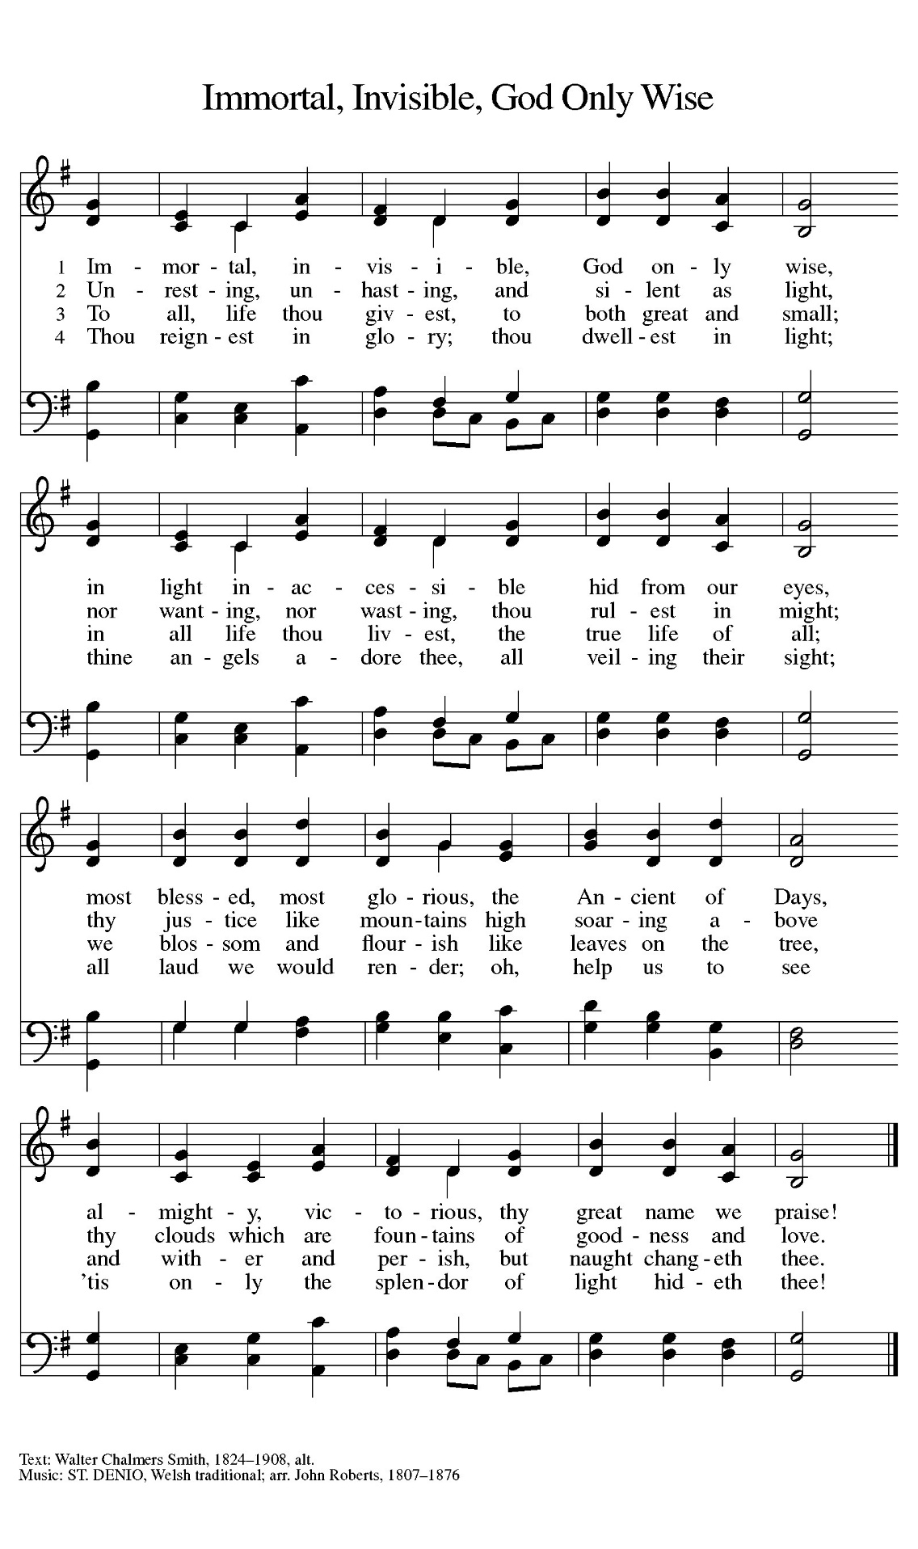

**GREETING**

P: The grace of our Lord Jesus Christ, the love of God, and the communion of the Holy Spirit be with you all.

**C: And also with you.**

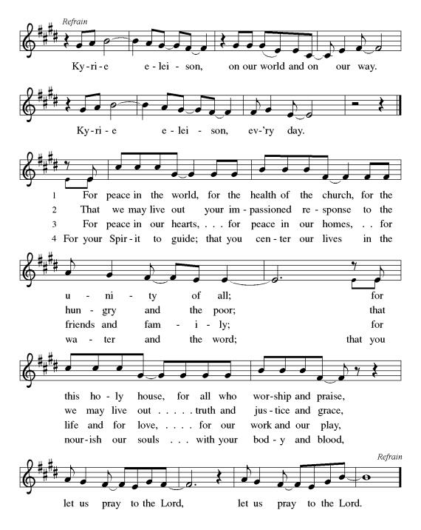

**KYRIE**

**HYMN OF PRAISE**

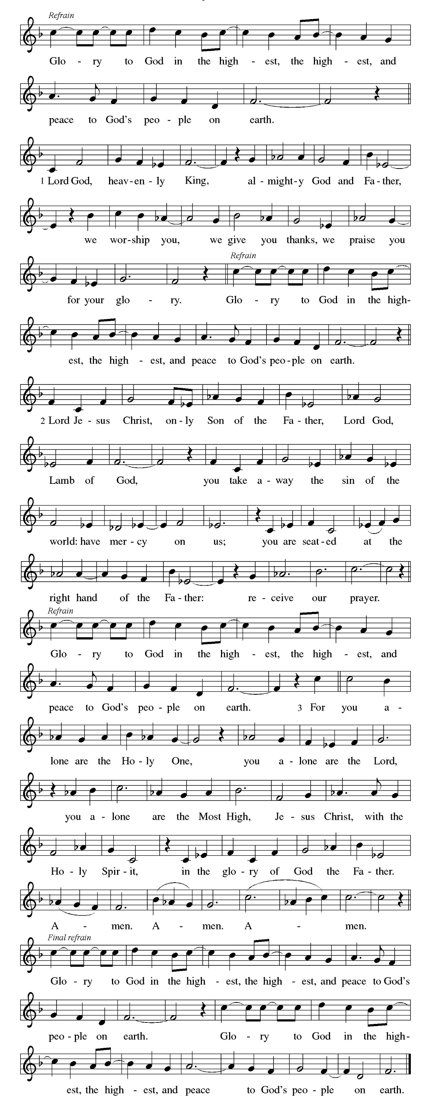

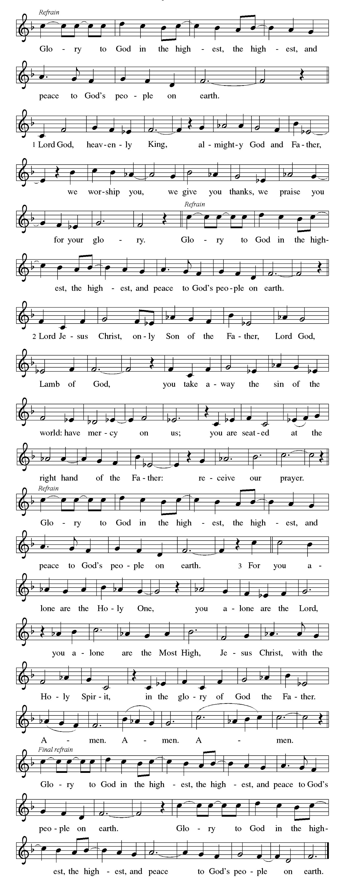

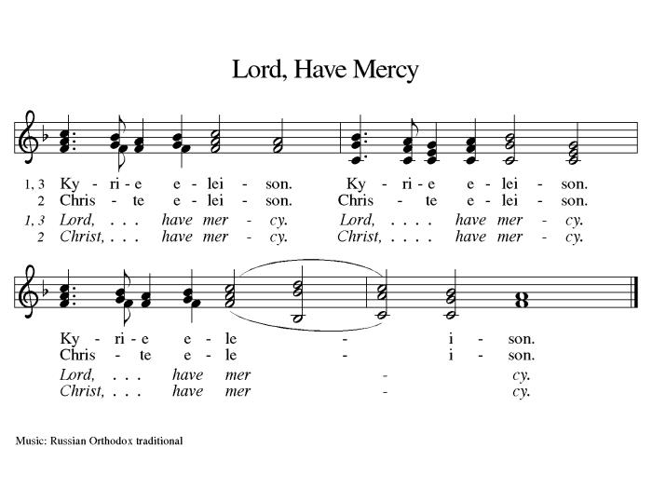**PRAYER OF THE DAY**

P: Let us pray,

**C: Bountiful God, you gather your people into your realm, and you promise us food from your tree of life. Nourish us with your word, that empowered by your Spirit we may love one another and the world you have made, through Jesus Christ, our Savior and Lord, who lives and reigns with you and the Holy Spirit, one God, now and forever.**

**Amen.**

**We Listen to God’s Word**

**FIRST READING Acts 16:9-15**

9 During the night Paul had a vision: there stood a man of Macedonia pleading with him and saying, “Come over to Macedonia and help us.” 10 When he had seen the vision, we immediately tried to cross over to Macedonia, being convinced that God had called us to proclaim the good news to them.  
  
  11 We set sail from Troas and took a straight course to Samothrace, the following day to Neapolis, 12 and from there to Philippi, which is a leading city of the district of Macedonia and a Roman colony. We remained in this city for some days. 13 On the sabbath day we went outside the gate by the river, where we supposed there was a place of prayer; and we sat down and spoke to the women who had gathered there. 14 A certain woman named Lydia, a worshiper of God, was listening to us; she was from the city of Thyatira and a dealer in purple cloth. The Lord opened her heart to listen eagerly to what was said by Paul. 15 When she and her household were baptized, she urged us, saying, “If you have judged me to be faithful to the Lord, come and stay at my home.” And she prevailed upon us.

L: Word of God, word of life.

**C: Thanks be to God.**

**PSALM** **Psalm** **67**

L: May God be merciful to us and bless us;  
  may the light of God’s face shine upon us.  
**C:** **Let your way be known upon earth,**  
  **your saving health among all nations.**  
L: Let the peoples praise you, O God;  
  let all the peoples praise you.  
**C:** **Let the nations be glad and sing for joy,**  
  **for you judge the peoples with equity and guide all the nations on earth.**  
L: Let the peoples praise you, O God;  
  let all the peoples praise you.  
**C:** **The earth has brought forth its increase;**  
  **God, our own God, has blessed us.**  
L: May God give us blessing,  
  and may all the ends of the earth stand in awe.

**SECOND READING Revelation 21:10, 22-22:5**

10 And in the spirit [one of the angels] carried me away to a great, high mountain and showed me the holy city Jerusalem coming down out of heaven from God.  
  22 I saw no temple in the city, for its temple is the Lord God the Almighty and the Lamb. 23 And the city has no need of sun or moon to shine on it, for the glory of God is its light, and its lamp is the Lamb. 24 The nations will walk by its light, and the kings of the earth will bring their glory into it. 25 Its gates will never be shut by day—and there will be no night there. 26 People will bring into it the glory and the honor of the nations. 27 But nothing unclean will enter it, nor anyone who practices abomination or falsehood, but only those who are written in the Lamb’s book of life.  
 22:1 Then the angel showed me the river of the water of life, bright as crystal, flowing from the throne of God and of the Lamb 2 through the middle of the street of the city. On either side of the river is the tree of life with its twelve kinds of fruit, producing its fruit each month; and the leaves of the tree are for the healing of the nations. 3 Nothing accursed will be found there any more. But the throne of God and of the Lamb will be in it, and his servants will worship him; 4 they will see his face, and his name will be on their foreheads. 5 And there will be no more night; they need no light of lamp or sun, for the Lord God will be their light, and they will reign forever and ever.

L: Word of God, word of life.

**C: Thanks be to God.**

*(Please stand)*

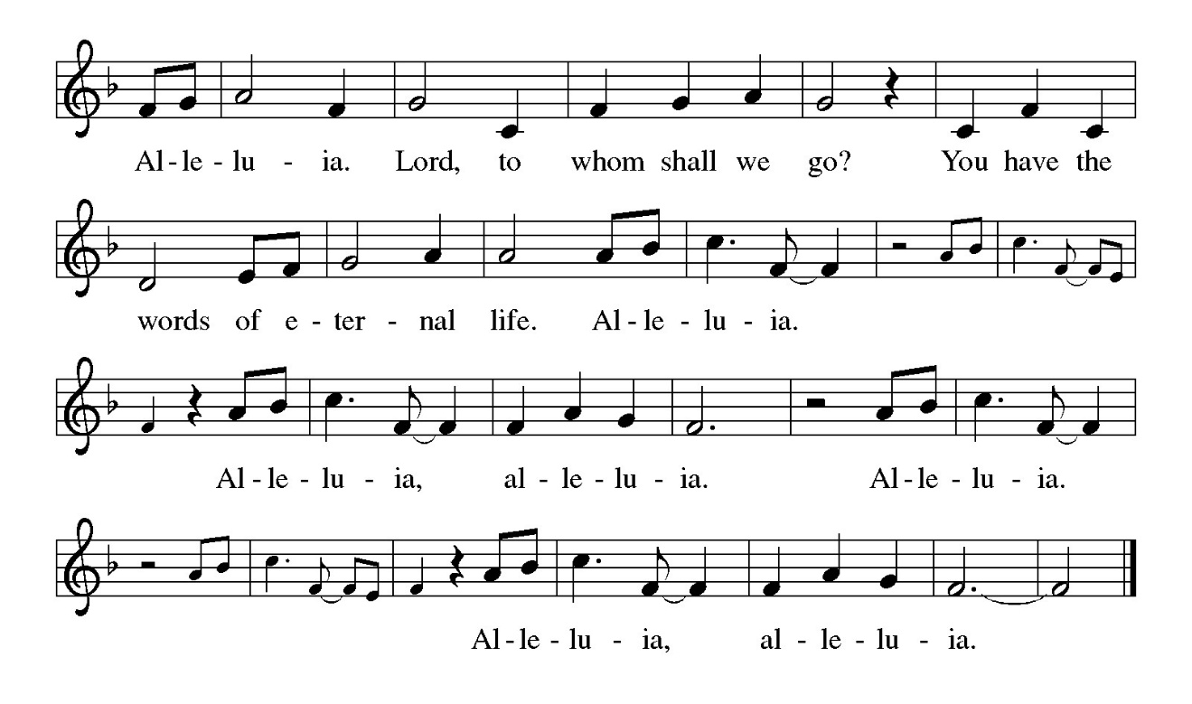**GOSPEL ACCLAMATION**

P: The Holy Gospel according to John the 14th chapter.

**C: Glory to you, O Lord**

*(Please be seated)*

**GOSPEL John 14:23-29**

23 Jesus answered [Judas (not Iscariot),] “Those who love me will keep my word, and my Father will love them, and we will come to them and make our home with them. 24 Whoever does not love me does not keep my words; and the word that you hear is not mine, but is from the Father who sent me.  
  25 “I have said these things to you while I am still with you. 26 But the Advocate, the Holy Spirit, whom the Father will send in my name, will teach you everything, and remind you of all that I have said to you. 27 Peace I leave with you; my peace I give to you. I do not give to you as the world gives. Do not let your hearts be troubled, and do not let them be afraid. 28 You heard me say to you, ‘I am going away, and I am coming to you.’ If you loved me, you would rejoice that I am going to the Father, because the Father is greater than I. 29 And now I have told you this before it occurs, so that when it does occur, you may believe.”

P: The Gospel of our Lord

**C: Praise to you, O Christ.**

*(Please be seated)*

**SERMON *Sem. Lotegeluaki Lengai***

*(Please stand)*

**HYMN OF THE DAY** *“Peace, To Soothe Our Bitter Woes”* **ELW Hymn 381**

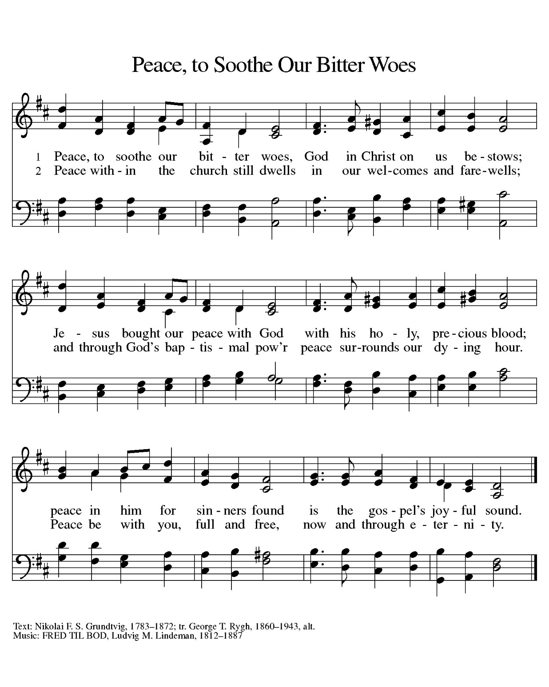

**HermansenWe Respond to God’s Word**

**NICENE CREED *(unison)***

**We believe in one God,**

**the Father, the Almighty,**

**maker of heaven and earth,**

**of all that is, seen and unseen.**

**We believe in one Lord, Jesus Christ,**

**the only Son of God,**

**eternally begotten of the Father,**

**God from God, Light from Light,**

**true God from true God,**

**begotten, not made,**

**of one Being with the Father;**

**through him all things were made.**

**For us and for our salvation**

**he came down from heaven,**

**was incarnate of the Holy Spirit and the virgin Mary**

**and became truly human.**

**For our sake he was crucified under Pontius Pilate;**

**he suffered death and was buried.**

**On the third day he rose again**

**in accordance with the scriptures;**

**he ascended into heaven**

**and is seated at the right hand of the Father.**

**He will come again in glory to judge the living and the dead,**

**and his kingdom will have no end.**

**We believe in the Holy Spirit, the Lord, the giver of life,**

**who proceeds from the Father and the Son,\***

**who with the Father and the Son is worshiped and glorified,**

**who has spoken through the prophets.**

**We believe in one holy catholic and apostolic church.**

**We acknowledge one baptism for the forgiveness of sins.**

**We look for the resurrection of the dead,**

**and the life of the world to come. Amen.**

*(Please Stand)*

**sharing of the peace**

P: The peace of the Lord be with you always.

**C: And also with you.**

*(Please be seated)*

**THE PRAYERS OF THE CHURCH**

*Each petition concludes:*

P: Hear us, O God,

**C: Your mercy is great.**

**HermansenWe Share in the Holy Meal**

*(Please Stand)*

**Dialogue**

P: The Lord be with you.

**C: And also with you.**

P: Lift up your hearts.

**C: We lift them to the Lord.**

P: Let us give thanks to the Lord our God.

**C: It is right to give our thanks and praise.**

P: It is indeed right, our duty and our joy…

…we praise your name and join their unending hymn:

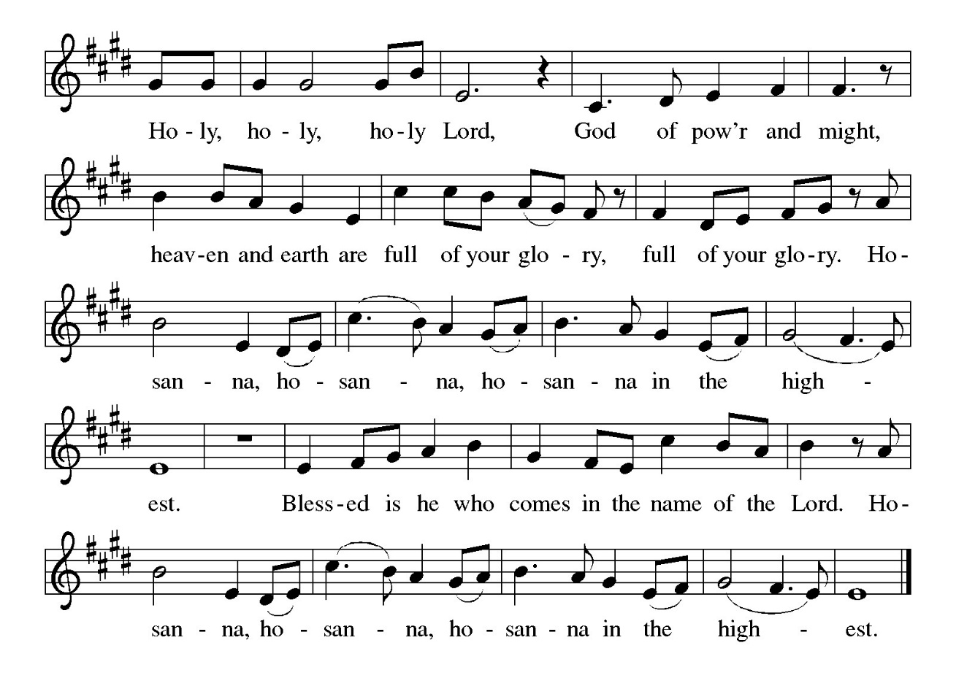

**WORDS OF INSTITUTION**

*(please stand)*

**THE LORD’S PRAYER *(unison)***

**Our Father, who art in heaven,**

**hallowed be thy name,**

**thy kingdom come,**

**thy will be done,**

**on earth as it is in heaven.**

**Give us this day our daily bread;**

**and forgive us our trespasses,**

**as we forgive those**

**who trespass against us;**

**and lead us not into temptation,**

**but deliver us from evil.**

**For thine is the kingdom,**

**and the power, and the glory,**

**forever and ever. Amen.**

**INVITATION TO COMMUNION**

P: Come to the table of grace. Receive the gift of new life.

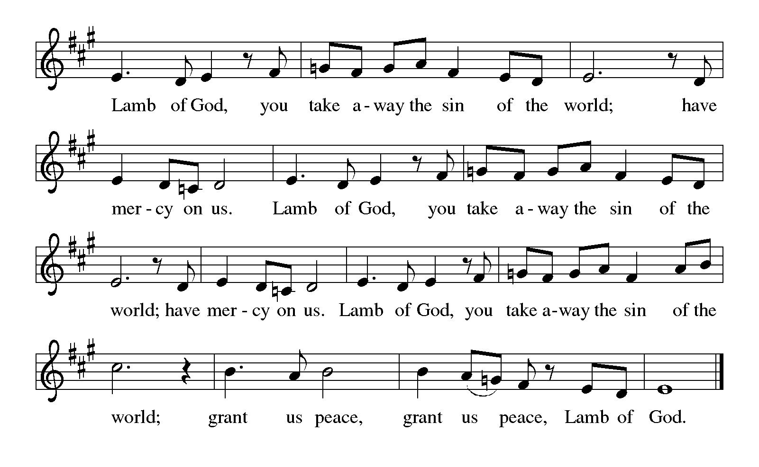*(Please be seated)*

**LAMB OF GOD**

**DISTRIBUTION BY INDIVIDUAL GLASSES**

***(Gluten-free wafers are available upon request.)***

*All who believe in the real presence of Christ in the sacrament are invited to commune. Children who do not commune are welcome to come for a blessing. You will be given a wafer. The glasses of dark liquid are wine; the middle ring is juice. There is a bowl of water if you would like to remember your baptism.*

**DISTRIBUTION HYMN** *“I’m So Glad Jesus Lifted Me”* **ELW Hymn 860**

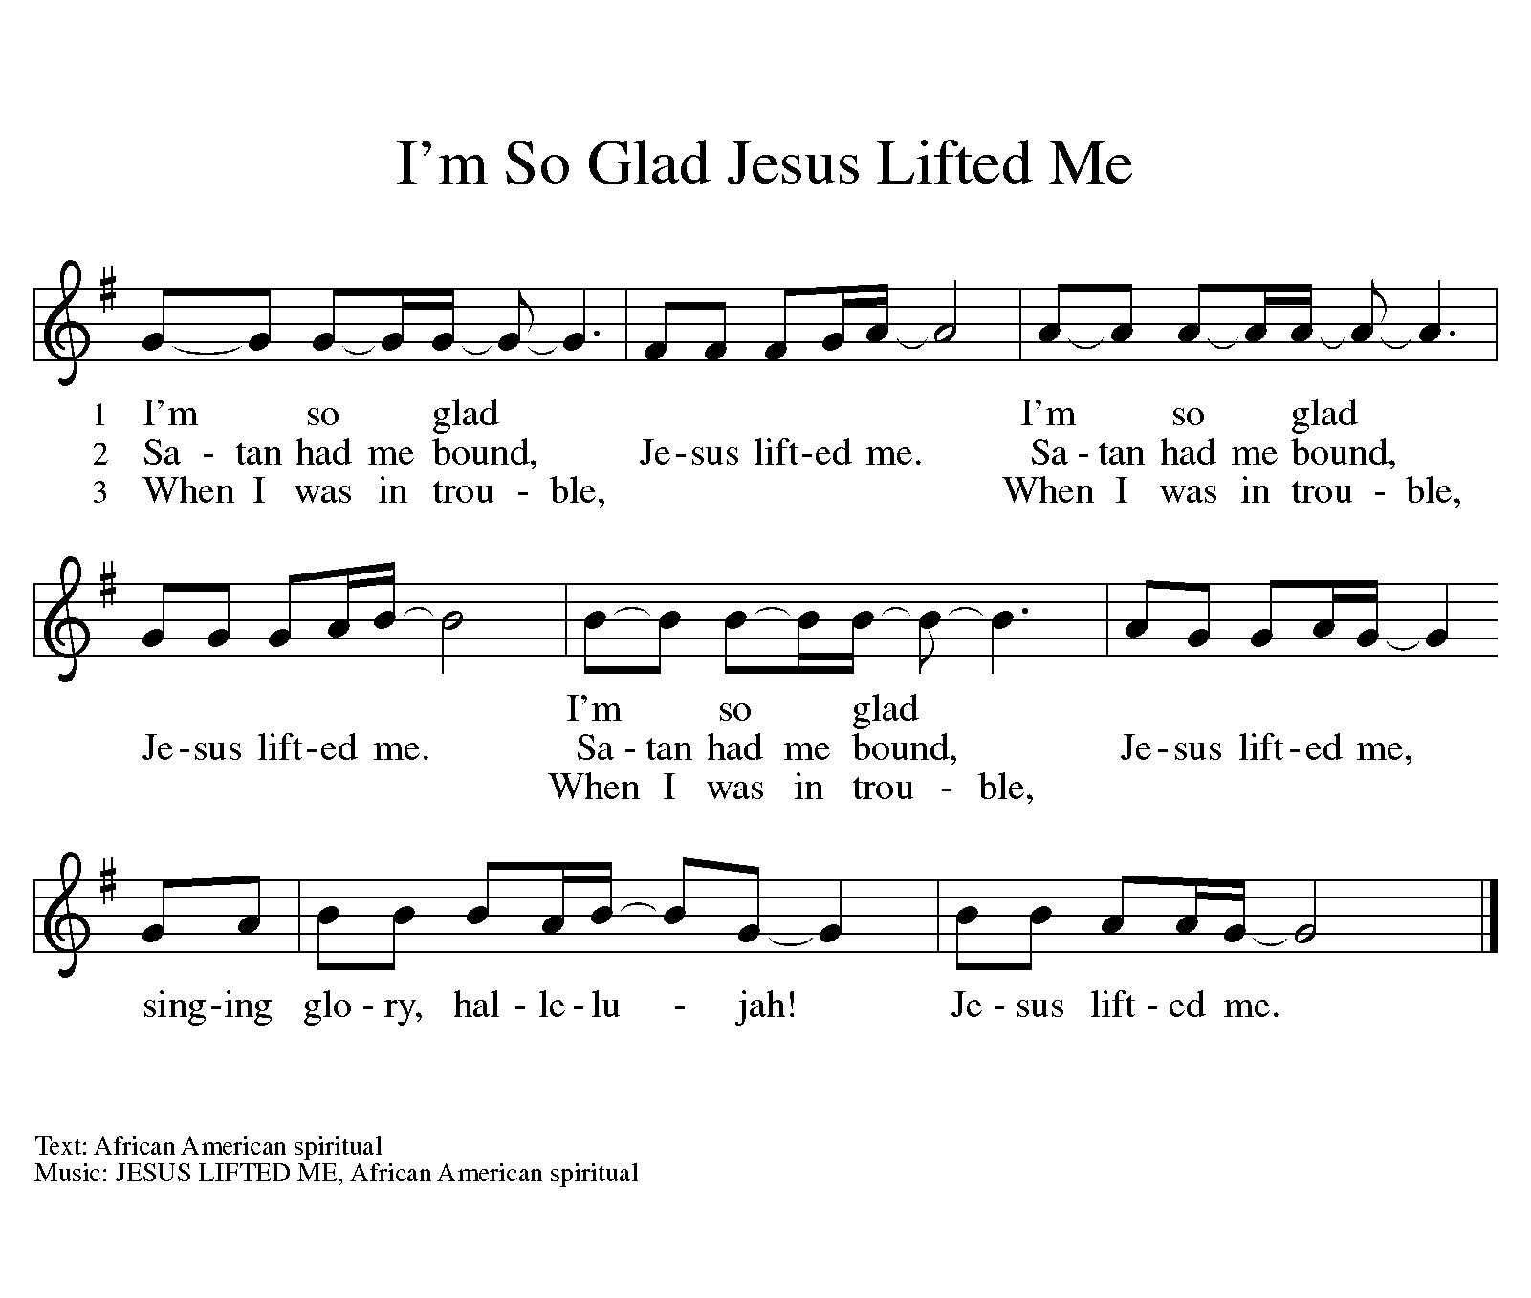

**DISTRIBUTION HYMN** *“Jerusalem, My Happy Home”* **ELW Hymn 628**

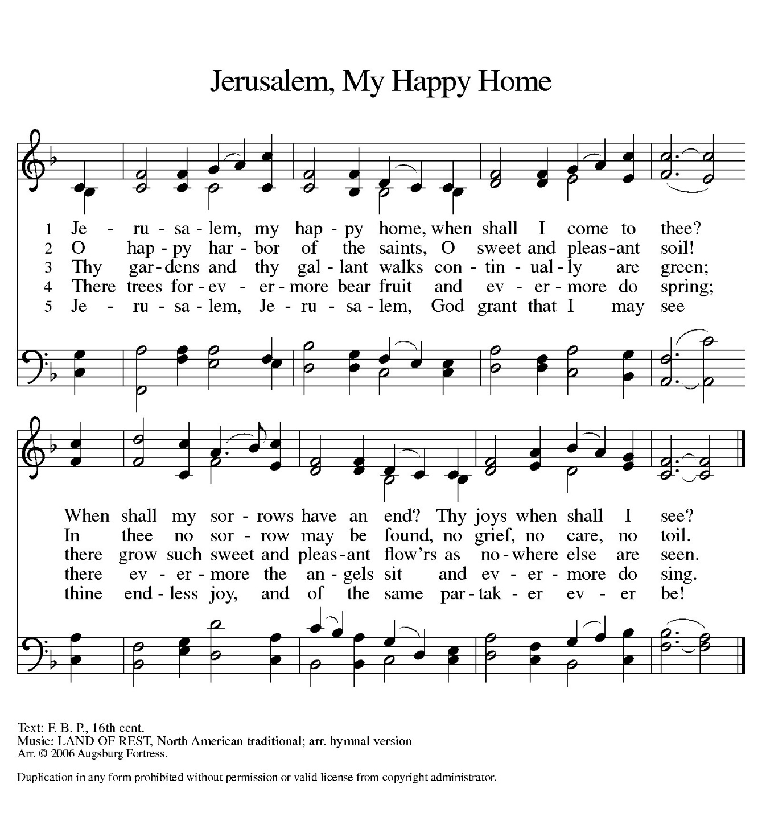

*(Please stand)*

**PRAYER AFTER COMMUNION**

P: Living One,

in this feast you have made yourself known to us.

Send us now to tell of your wonders,

sing of your glory,

and proclaim your risen life

to a wounded and weary world.

**C: Amen.**

**ANNOUNCEMENTS**

**BLESSING**

P: The God of steadfastness and encouragement grant you to live in harmony with one another, in accordance with Christ Jesus.

**C: Amen.**

**P:** The God of hope fill you with all joy and peace in believing, so that you may abound in hope by the power of the Holy Spirit.

**C: Amen.**

P: The God of all grace ☩ bless you now and forever.

**C: Amen.**

**CLOSING HYMN** *“We Are Marching in the Light of God”* **ELW Hymn 866**

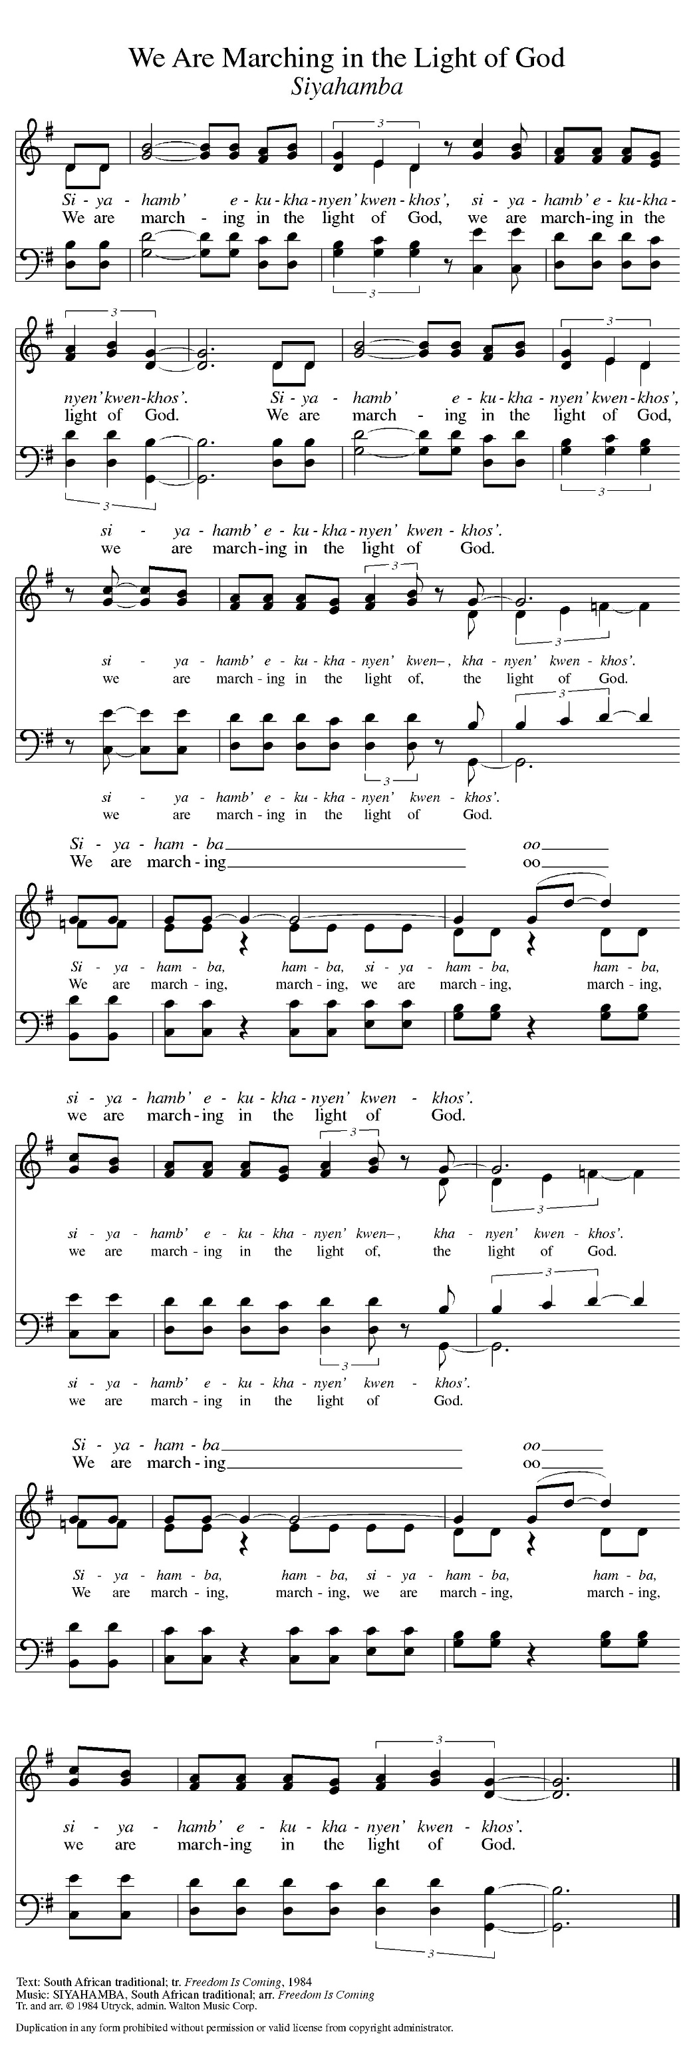

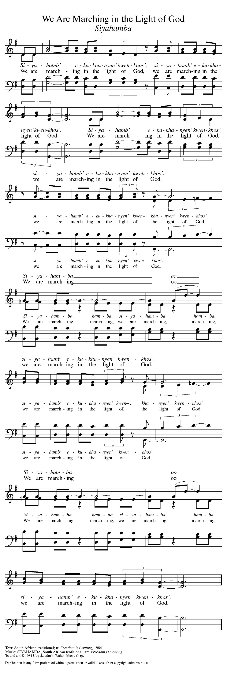

**the Dismissal**

P: Alleluia! Christ is risen.

**C: Christ is risen indeed. Alleluia!**

**P: Go in peace. In Christ you are made new. Alleluia! Alleluia!**

**C: Thanks be to God. Alleluia! Alleluia!**

**POSTLUDE**

************************

Used by permission of Augsburg Fortress SundaysandSeasononline.com license #25124

Reprinted from *Sundays and Seasons* copyright © 2025 Augsburg Fortress

**WORSHIP ASSISTANTS**

Lector: Mike Hopp

Usher: Susan Swanson

Communion: Jessica King; Bill Mundt

arken; H

Greeters: Dan & Julie Wischmeier

Missionary Support: Open

Altar Flowers: Carol Dodge

Remember in prayer: Eleonore Benninghoven; Jim & Bev Felland; Genieve Hingst

~ ~ ~ ~ ~ ~ ~ ~ ~ ~ ~ ~ ~ ~ ~ ~ ~ ~ ~ ~ ~ ~

A Cry Room for infants is available up the stairs and to the right.

There are Kids Celebrate children’s bulletins available for youngsters

who’d like to have their own reference to the lessons for this week.

Ask our usher for help.

Please join us for coffee and donuts in the fellowship

hall following the worship service. We would like to

get to know you and offer our friendship.

~ ~ ~ ~ ~ ~ ~ ~ ~ ~ ~ ~ ~ ~ ~ ~ ~ ~ ~ ~ ~ ~

**ACTIVITIES FOR THE WEEK**

*Today's gospel combines a saying that makes many of us uncomfortable with a story we find comforting. Jesus' saying on divorce is another of his rejections of human legislation in favor of the original intent of God's law. Jesus' rebuke of the disciples who are fending off the children should challenge us as well. What does it mean to receive the kingdom of God as a child does?*

*Today's gospel combines a saying that makes many of us uncomfortable with a story we find comforting. Jesus' saying on divorce is another of his rejections of human legislation in favor of the original intent of God's law. Jesus' rebuke of the disciples who are fending off the children should challenge us as well. What does it mean to receive the kingdom of God as a child does?*

Today: **Sixth Sunday of Easter**

**Sem. Lotegeluaki Lengai preaching w/ Pastor Ralph**

**Andersen presiding**

9:00 a.m.Worship with Holy Communion

10:55 a.m. Lutheran Church of Hope Service

**Monday: Office Closed in observance of Memorial Day!**

Next Sunday: **Rogation Sunday**

9:00 a.m. Worship with Holy Communion

**10:15 a.m. Church Outreach**

10:55 a.m. Lutheran Church of Hope Service

**PULPIT SUPPLY**

Pastor Misha will be away on vacation from May 18-May 31! On May 18, Todd Chelf will be preaching-there will not be Communion on that Sunday. On May 25, Lotegeluaki Lengai will be preaching with Pastor Ralph Andersen presiding!

**PASTORAL COVERAGE WHILE PASTOR MISHA IS ON VACATION**

Pastor Mark Youngquist will be providing Pastoral coverage for any Pastoral emergencies that may arise while Pastor Misha is on vacation from May 18-May 31. He can be reached at 319-631-8564.

**OUTREACH FOOD PANTRY DONATIONS**

June donations will be any non-perishable food items! Thank you all for your generosity!

**EWALU SUMMER CAMP**

Messiah has invited Bethany youth to join their youth at camp this summer at Strawberry Point, IA from July 27-Aug. 1! Any Bethany youth interested in going to summer camp this year, you can pick up a brochure for EWALU Summer Camp and follow the QR code to register online! There is a place to enter who your camp buddy is, just put Messiah in that field and please let Laura Carruthers at Messiah know you are going. She can also coordinate with you on carpooling up to camp and back home. If you have any questions, please feel free to contact Laura Carruthers at 319-759-4377.

**VACATION BIBLE SCHOOL**

Vacation Bible School at Messiah is coming up June 16-19 for ages 3yrs to 6th grade! There is a flyer on the bulletin board in the hallway & in the May Chimes Newsletter with more information and a QR code to register online! We also have some copies of the registration form on the table outside of the Sanctuary! Volunteers will use the same registration form. Also, there is a sign up sheet for supplies items needed on that same table as well!

**PASTOR’S BOOK CLUB!**

Pastor’s Book Club will meet next on Tuesday, June 10 @ 7pm @ Bethany. Our next book for June will be “In The Margins: A Transgender Man’s Journey with Scripture” By Shannon T.L. Kearns!

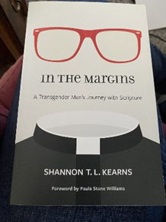

**~ ~ ~ ~ ~ ~ ~ ~ ~ ~ ~ ~ ~ ~**

B*ethany Lutheran Church*

*2515 Madison Ave., Burlington, IA Phone: (319) 752-3621*

*www.bethanyburlington.org*

*Office Hours*

*Monday-Wednesday-Friday – 9:00am-1:00pm*

*Tuesday & Thursday – 1:30pm-4:30pm*

*Pastor Misha’s Office Hours*

*Bethany: Monday & Tuesday*

*Messiah: Wednesday & Thursday*

***\*Pastor Misha’s hours vary in the office from***

***week to week as she may be out of office on visits or other***

***Pastor duties. Please call or text her to make an appointment or to***

***see if she is in the office.\****

***Pastor Misha’s contact info: 412-628-6382; damisha.mcfarlandpollock@gmail.com***

**~ ~ ~ ~ ~ ~ ~ ~ ~ ~ ~ ~ ~ ~**

**Our Staff**

Rev. Misha McFarland-Pollock Pastor

Cory Byrne Organist/Choir Director

Kim Engle Stephen Minister Coordinator

Wendy Bell Office Administrator

Michelle Huppenbauer Financial Secretary

Pam Crable Custodian